PHISHING AWARENESS SIMULATION
USING SOCIAL ENGINEERING TECHNIQUES
Major Project – Cybersecurity Internship
Academic Project Report
Prepared by: Yash and Sharyu Pravin Ghorpade

Abstract
Phishing is a social-engineering technique in which an attacker attempts to manipulate a user into clicking a malicious link, opening an attachment, or disclosing sensitive information. This project develops a safe phishing-awareness simulation that reproduces common warning signs without sending real phishing messages or collecting real credentials. A local HTML/CSS/JavaScript application presents a simulated account-warning email, a demonstration login page, and a results dashboard. The project measures three primary behaviors: link clicks, demonstration data-entry attempts, and reports. A sample dataset of 30 synthetic participants is included to demonstrate analysis. The results show how behavioral metrics can be used to identify awareness gaps and guide countermeasures such as verification through known channels, multi-factor authentication, security awareness training, and phishing-resistant authentication.
Keywords: Phishing, Social Engineering, Cybersecurity Awareness, MFA, Security Training, HTML, JavaScript

1. Introduction
Phishing attacks exploit trust, urgency, fear, curiosity, or familiarity rather than relying only on technical vulnerabilities. The Federal Trade Commission explains that phishing messages often tell a story designed to make a person click a link or open an attachment and may impersonate a familiar organization. Common warning signs include unexpected requests, account problems, urgent action, and requests for sensitive information.
This project translates those concepts into an ethical laboratory exercise. Instead of sending a real phishing message, the project uses a local web application. The participant can see a simulated message, make a choice, and receive an educational explanation. The system records only behavioral counters and never stores the values entered into the demonstration form.

2. Problem Statement
Users may recognize obvious phishing attempts but still interact with convincing messages when they contain urgency, account warnings, generic greetings, or familiar-looking login requests. Organizations therefore need a practical way to assess awareness while protecting participants and avoiding collection of real credentials.

3. Objectives
- Understand common phishing and social-engineering techniques.
- Design a realistic but harmless phishing-style email for demonstration.
- Create a local demonstration login page using basic HTML/CSS.
- Measure clicks, demonstration data-entry attempts, and reports.
- Analyze the observed behavior using simple percentages.
- Recommend preventive measures and awareness practices.
- Demonstrate ethical boundaries for cybersecurity testing.

4. Background and Literature Review

4.1 Phishing techniques
Common phishing approaches include impersonation, fake account alerts, payment or invoice themes, password-reset requests, malicious links, and urgency. The FTC recommends not clicking unexpected links or attachments and instead contacting the organization using a phone number or website known to be genuine.

4.2 Authentication as a mitigation
Multi-factor authentication adds another verification step, reducing the impact of stolen passwords. NIST's current digital identity guidance emphasizes phishing-resistant authenticators for phishing and pharming threats. CISA guidance also recommends prioritizing phishing-resistant MFA for privileged accounts and using centralized identity controls such as SSO where appropriate.

4.3 Security awareness
Technical controls are strongest when combined with user awareness. Training should teach users to pause, inspect unexpected requests, verify through an independent channel, report suspicious messages, and avoid reusing passwords.

5. Methodology

5.1 System architecture
The system consists of four local pages: a project landing page, a simulated email page, a demonstration login page, and a results dashboard. JavaScript uses browser localStorage only for aggregate counters. The application does not communicate with a backend server.
Flow: Landing Page → Simulation Email → User Decision → Demonstration Login (optional) → Local Results Dashboard

5.2 Simulation design
- Sender identity uses a reserved .example domain and does not impersonate a real organization.
- The email contains generic greeting, urgency, account-warning language, and a login link.
- The login page clearly identifies itself as a simulation.
- The form submission handler prevents network submission and discards the entered values.
- Only the event 'data-entry attempt' is counted.
- The dashboard shows aggregate counts and a click rate.

5.3 Ethical controls
- Informed consent is required before any participant test.
- No real credentials or sensitive information are requested.
- No real company branding is used.
- No external email delivery is included.
- No hidden tracking pixels or third-party analytics are used.
- Results should be anonymized and reported in aggregate.

6. Implementation

6.1 Technologies
Technology | Purpose | Implementation
HTML5 | Page structure | index.html, email.html, login.html, result.html
CSS3 | User interface | styles.css
JavaScript | Local event tracking | app.js
Python | Data analysis | analysis/analyze.py
Pandas/Matplotlib | Metrics and chart | Demo dataset analysis

6.2 Demonstration login behavior
When the form is submitted, JavaScript prevents the normal HTTP form submission. The event counter is incremented, the form is reset, and an educational message explains that the values were discarded. This design intentionally prevents credential harvesting.

7. Results and Analysis
The repository includes a synthetic demonstration dataset containing 30 anonymized participant IDs. It is included only to demonstrate the analysis workflow and must not be presented as a real classroom study. If the project is tested with actual participants, the synthetic dataset should be replaced by consented, anonymized results.
Metric | Demonstration result
Participants | 30
Clicked link | 24
Click rate | 82.8%
Demo data-entry attempts | 10
Data-entry rate | 34.5%
Reported | 9
Report rate | 31.0%
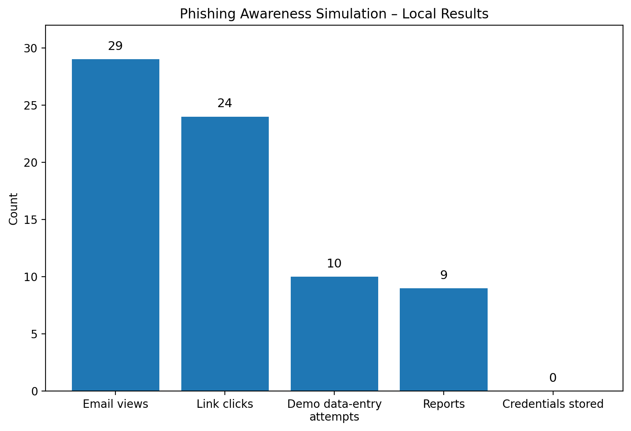
Figure 1. Synthetic demonstration results (n=30).

8. Findings
In the synthetic dataset, 24 of 29 participants clicked the simulated link, producing a 82.8% click rate. Ten participants attempted to submit the demonstration form, producing a 34.5% data-entry attempt rate. Nine participants reported the message, producing a 31.0% report rate. These figures are illustrative only and should not be interpreted as measured awareness of a real group.
- Clicking alone does not prove that a participant would disclose real credentials.
- A data-entry attempt is a stronger indicator of risky behavior and can guide targeted training.
- Reporting behavior is an important positive security outcome.
- Training should emphasize verification and reporting rather than blaming participants.

9. Lessons Learned
- Social engineering can make technically simple messages persuasive by creating urgency.
- A safe simulation can demonstrate the behavior without collecting credentials.
- Metrics help convert awareness training into measurable outcomes.
- Phishing defense should combine people, process, and technology.
- Authentication controls such as MFA reduce the consequences of password compromise.
- Phishing-resistant authentication is preferable where supported, especially for privileged accounts.

10. Preventive Measures
Measure | Recommendation
User awareness | Train users to pause, inspect unexpected requests, verify through known channels, and report suspicious messages.
MFA | Enable MFA broadly; prioritize phishing-resistant methods for privileged and high-value accounts.
Email security | Use spam/phishing filtering, attachment scanning, URL protection, and sender authentication controls.
Least privilege | Limit account permissions so a compromised user cannot access unnecessary systems or data.
Password hygiene | Use unique passwords/passphrases and a password manager; never reuse passwords.
Patch management | Keep operating systems, browsers, applications, and security tools updated.
Incident response | Define a simple process for reporting suspicious messages and quickly resetting compromised credentials.
Backups | Maintain tested backups to reduce the impact of ransomware or destructive incidents.

11. Limitations
- The included dataset is synthetic and not a real participant study.
- The application is intentionally local and therefore does not simulate enterprise email-delivery infrastructure.
- LocalStorage metrics are simple and can be reset by the user.
- A single scenario cannot represent every phishing technique.
- Real-world validation should use formal authorization, consent, privacy controls, and institutional policies.

12. Future Enhancements
- Add multiple consent-approved scenarios such as invoice, password-reset, and delivery themes.
- Add a pre-test and post-test awareness questionnaire.
- Add an instructor-only export of anonymized aggregate results.
- Add role-based scenarios for students, employees, and administrators.
- Add a training module that explains each phishing cue immediately after the exercise.

13. Conclusion
The project demonstrates how a phishing-awareness exercise can be built with basic web technologies while maintaining strong ethical safeguards. The local simulation reproduces common social-engineering cues, measures behavioral outcomes, and immediately teaches safer behavior. The main lesson is that phishing defense is not a single control: awareness, reporting, email security, least privilege, and strong authentication must work together.

14. References
- Federal Trade Commission. How To Recognize and Avoid Phishing Scams. https://consumer.ftc.gov/articles/how-recognize-avoid-phishing-scams
- Federal Trade Commission. Protect yourself from phishing scams. https://consumer.ftc.gov/consumer-alerts/2025/04/protect-yourself-phishing-scams
- Federal Trade Commission. Phishing Scams. https://www.ftc.gov/news-events/topics/identity-theft/phishing-scams
- NIST. Special Publication 800-63B, Digital Identity Guidelines – Authentication and Lifecycle Management. https://pages.nist.gov/800-63-4/sp800-63b.html
- CISA. Phishing Guidance: Stopping the Attack Cycle at Phase One. https://www.cisa.gov/sites/default/files/2025-03/Phishing%20Guidance%20-%20Stopping%20the%20Attack%20Cycle%20at%20Phase%20One%20508.pdf
- CISA. Identity and Access Management: Recommended Best Practices for Administrators. https://www.cisa.gov/sites/default/files/2023-12/ESF%20IDENTITY%20AND%20ACCESS%20MANAGEMENT%20RECOMMENDED%20BEST%20PRACTICES%20FOR%20ADMINISTRATORS%20PP-23-0248_508C.pdf

Appendix B – Repository Contents
The repository includes source code, synthetic data, analysis code, a consent form, screenshots, a report, a presentation, and local run scripts. The README provides the setup and ethical-use instructions.

Appendix A – Screenshots

